
Attendance Policy

Version Number | 1
Author of Policy | Phillip Sales (Headteacher)
Date Published | September 2025
Date for Review | September 2026
Signed and Date |   September 2025

This policy is underpinned by our school motto:

"The roots to grow, the wings to fly"



Introduction
We aim to ensure that all children attend school regularly and on time to enable them to take full advantage of the educational opportunities available. Regular, punctual attendance is valued and positively encouraged for all of our pupils.

Some pupils find it harder than others to attend school. This policy sets out how school staff will work with pupils, parents, and partners to promote, encourage and support regular attendance at school and remove any barriers to attendance. We as a school have fully considered our obligations under the Equality Act 2010 and considerations under the UN Conventions on the Rights of the Child.

Our Aims
•To set clear expectations and aspirations that all pupils have a high standard of
school attendance and punctuality.
•To improve children’s attainment through good attendance.
•To make attendance a priority for everyone.
•To ensure there is a clear process to identify and address emerging attendance
concerns
•To work effectively with parents, pupils, and partners through building trusted
relationships to work together to remove barriers to attendance.

School Data % and Target from academic year 2024-25
School | Local Authority | national | Target
95.2% | 95% | 95.10% | 97%

To achieve these aims for our pupils, we are committed to the following:
•a welcoming, stimulating and safe learning environment;
•for all staff to feel happy to come to school to work with pupils, developing them to
their full potential;
•listen to parents and pupils to understand barriers to attendance
•build trusted relationships with parents and pupils where attendance concerns can
be discussed, understood.
•high expectations of our pupils and all staff;
•a broad, balanced and relevant curriculum;
•recognise and celebrate achievements in all areas of school life;
•equal access to all aspects of the curriculum and school life;
•high quality teaching using a variety of teaching strategies;
•a range of resources that are effectively used to support and challenge learning;
•provide experiences, which will develop our pupils’ spiritual, moral and cultural understanding;
•support, guidance and training for all those who teach and work with our children;
•foster and maintain links with our wider community.

WHY ATTENDANCE IS IMPORTANT

Learning:
Learning at our school is inclusive, interactive and sequential, requiring the participation of the pupils with the teacher and peers during learning time. This is affected when a pupil is absent or persistently late – not only for that pupil, but for the dynamics of the entire class. This is both during their absence as well as upon their return, when time is taken to reintegrate them into the learning context of the class. Additionally, catch up tasks can help make up for lost work, but cannot replicate the discussions led by the teacher and/or children, questions raised by other pupils, or the activities conducted in class.

Safeguarding:
Children may be considered at risk if they do not attend school regularly. Safeguarding the interests of each child is everyone’s responsibility. Within the context of this school, promoting the welfare and life opportunities for every pupil encompasses: Attendance, Strong Relationship Management, Health and Safety, Access to the Curriculum and Anti-bullying. Not attending school on a regular basis will be considered as a safeguarding matter.

The Law relating to attendance:
Section 7 of the Education Act 1996 states that ‘the parent of every child of compulsory school age shall cause him / her to receive full-time education suitable: (a) to age, ability and aptitude and (b) to any special educational needs he/ she may have, either by regular attendance at school or otherwise’

The Law relating to safeguarding:
Section 175 of the Education Act 2002 places a duty on local authorities and governing bodies to have regard to guidance issued by the Secretary of State with regard to safeguarding and promoting the welfare of children and students under the age of 18.

Expected Levels of Attendance:
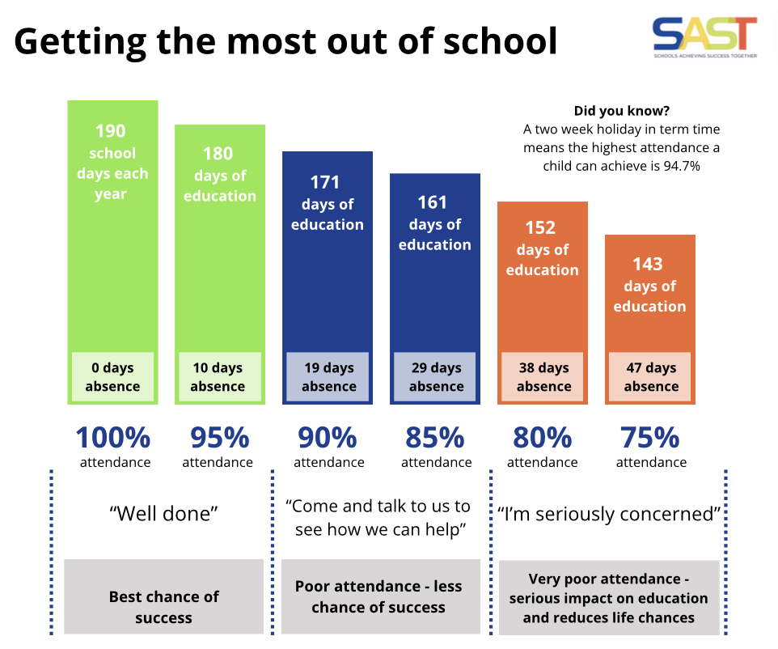
Attending school regularly and on time has a positive impact on learning, progress and therefore the best life chances for pupils. Research shows that attendance and punctuality are important factors in school success.

School Day and Punctuality

Our school day begins at 8:45am and finishes at 3:15pm.

Children who arrive between 8.45am to 8:50am will be marked present.

Children who arrive after 8.50am but before 9am will be marked as late (code L) on the register.

If a child arrives at school after the registration session has ended, they must immediately go to the school office to sign in and provide a reason for the lateness.

Children will usually be accompanied by their parent/s if late after the registration session has ended. In the absence of a satisfactory explanation, the register will be marked as unauthorised late absence (code U). A ‘U code’ constitutes an unauthorised absence for the whole morning or afternoon session. Legal action may be taken for continued U code absences.

Vulnerable pupils should always be accompanied to their first lesson by a member of school staff in order to ensure they are settled in their learning.

It is important that pupils are punctual so that they do not miss out on the beginning of each school day. Children must attend on time to be given a present mark for the start of the day.

If a pupil arrives late to school every day, their learning begins to suffer.

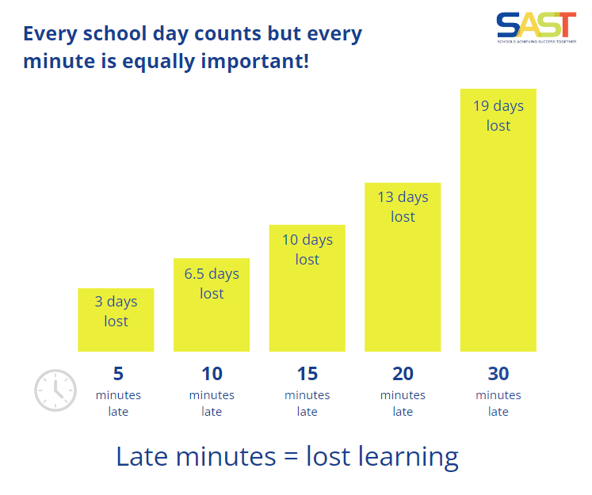
Below is a graph showing how being late to school every-day over a school year adds up to lost learning time.

Attendance Partnership Expectations

We expect the following from all of our pupils:
• To attend school regularly
• To arrive on time and appropriately prepared for the day, ready to learn.
• To talk to a member of staff about any problem or reason that may prevent them from attending school

Celebration and Expectation
We believe that celebrating attendance is key; whether our children have met our goals of attending school everyday, or have made great strides to attend regularly in spite of contributing factors outside of their control.
We will also share whole school attendance information on our weekly Buckland Bulletin Newsletter to update to Parents and Carers to keep everyone informed. Teachers will share pupils' individual figures for attendance at Parent Meetings in the Autumn and Spring Term. This will then be published and shared at the end of Year in each child’s End of School year Report.

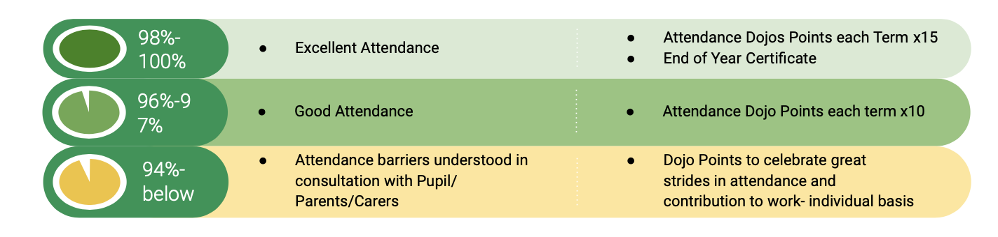

We expect the following from parents and carers:
• To ensure their children attend school regularly and punctually
• To notify the school of your child’s absence- on each morning of absence and provide a specific reason for the absence.
• To ensure that their children arrive in school well prepared for the school day
• To talk to a member of school staff about any problem or reason that may prevent them from attending school
• Inform the School of up-to-date contact numbers and details.

Schools are required to hold more than one emergency contact per child (KCSIE 2024).

Emergency contact numbers should be provided and updated by the parent with whom the pupil normally resides.

Parents and pupils can expect the following from school:
•Early contact with parents when a pupil fails to attend school without providing good reason;
•Regular, efficient and accurate recording of attendance
•To inform parents if a pupil’s attendance falls below expected levels
•To listen and understand the barriers to school attendance and offer appropriate support and agree appropriate plans to improve attendance.
•Follow up support if needed.
•When a child is absent and the school cannot contact parents, those leading schools/responsible for attendance matters or safeguarding, will continue to try and make contact. Where necessary (and by the third day of absence at the latest), they will make a welfare visit to the home address to confirm the safety of the child. A record of attempts and contact will be made on the school’s system.
.It is the requirement of school to inform the Local Authority when a child has 15 days absence due to illness, cumulative or consecutive - or when it is believed they will be unable to attend (The “section 19” duty)

Roles and Responsibilities for Attendance Champion
•Buckland Newton has an Attendance Champion, a named senior member of staff with responsibility for attendance issues.
•Members of school staff, both teaching and non-teaching, have responsibility for attendance issues in school.
•If you have a concern about your child’s attendance your first point of contact is
Mr Sales You can contact Mr Sales through the school office on 01935 476515 or alternatively through our email at office@bradfordabbas.dorset.sch.uk
Please DO NOT use School Dojo for attendance communications.
•Attendance matters are reviewed by the Headteacher, Deputy Head of School and the school SENCO
•Attendance issues are reported, on a minimum termly basis, to the Academy Committee (Governing body) .
•School will liaise with the Local Authority Attendance Support Team at a minimum, termly. We also are well supported by our Academy SAST Directors including the Head of Safeguarding who support, especially in complex cases. Their role encompasses monitoring, supporting and challenging the school.

Our Whole School Approach
ROLES | RESPONSIBILITIES
Academy Committee | • Ensure compliance with relevant legislation (e.g. pupil registration,  attendance registers)  • Reviewing school attendance  • Agreeing and Reviewing School Policy
Headteacher/ Deputy Headteacher | • Warm welcome  • Compliance with relevant legislation  • Data analysis  • Implementing school policy and leading on a whole school approach.  • Authorising/authorising absences  • Leave of absence request  • Line management  • Contact with parents  • Overview of clear and escalating interventions  • Evaluation of interventions.  • Promoting school attendance.  • Responsibility for links with Executive Head Teacher and where  appropriate SAST and the LA Statutory Team.  • Attendance at attendance panels  • Designated Safeguarding Lead
Class Teachers | • Warm welcome  • Marking registers  • Promoting importance of regular school’s attendance  • Providing early warning of attendance concerns  • Positive role modelling  • Following policy and procedures consistently  • Share attendance % at Autumn and Spring Term Parent Evenings.  • Point of contact for parents to discuss concerns
Office Attendance Lead | • Warm welcome  • Part of Attendance Team - implementing whole school approach  • Meetings with LA Inclusion Officer to review individuals/families and  concerns  • Part of Attendance Team - implementing whole school approach  • Coordinating School Office Team  • Decisions on and administration of school attendance letters, leave of  absence letters etc.
School office | •Warm welcome  •Maintaining registers  • First day calling/text messages  • Identifying children whose absence needs further follow up action in line  with the school absence procedure  • Late arrivals  • Process for clearing registers

Procedures
Our school procedures follow the expectations set out by the Department for Education in the guidance School Attendance (Pupil Registration) (England) Regulations (2024).

Our procedures are based around the principles and stages of:
•Preventing poor attendance
•Early intervention and Early Help to address early patterns of poor attendance and agree ways to improve
•Targeted interventions (including Early Help and Formal interventions) for those children who are persistently absent or severely absent
•Understanding barriers to individuals’ attendance and agree individual plans for children with specific needs.
•Formal Statutory Interventions where support has not been effective or engaged with.

Where attendance has deteriorated rapidly, there are concerning patterns of absence, unauthorised absences, or parents have not responded to concerns raised, a referral may be made straight to the Dorset County Council Inclusion Officer for the attendance process for addressing attendance concerns and where appropriate legal action including the issue of penalty notices will be followed.

Many children will experience normal but difficult emotions that make them nervous about attending school, such as worries about friendships, schoolwork, examinations or variable moods. It is important to note that these pupils are still expected to attend school regularly - in many instances, attendance at school may serve to help with the underlying issues such as being away from school might exacerbate it, and a prolonged period of absence may heighten anxious feelings about attending in future.

School staff play a critical role in communicating this expectation to parents. We will work alongside families to ensure that such circumstances do not act as a barrier to regular attendance by mitigating anxious feelings in school as much as possible.

Some pupils face more complex barriers to attendance. This can include pupils who have long term physical or mental health conditions or who have special educational needs and disabilities (SEND). Their right to an education is the same as any other pupil and therefore the attendance ambition for these pupils should be the same as it is for any other pupils but additional support may need to be provided.

In developing this support, the usual processes relevant to any attendance case apply:
•Understanding the individual needs of the pupil and family
•Working in partnership with the pupil and family to put in-school support in place
and working with other the local authority and other agencies where external
support is needed (and available)
•Regularly reviewing and updating the support approach to make sure it continues to
meet individual needs.
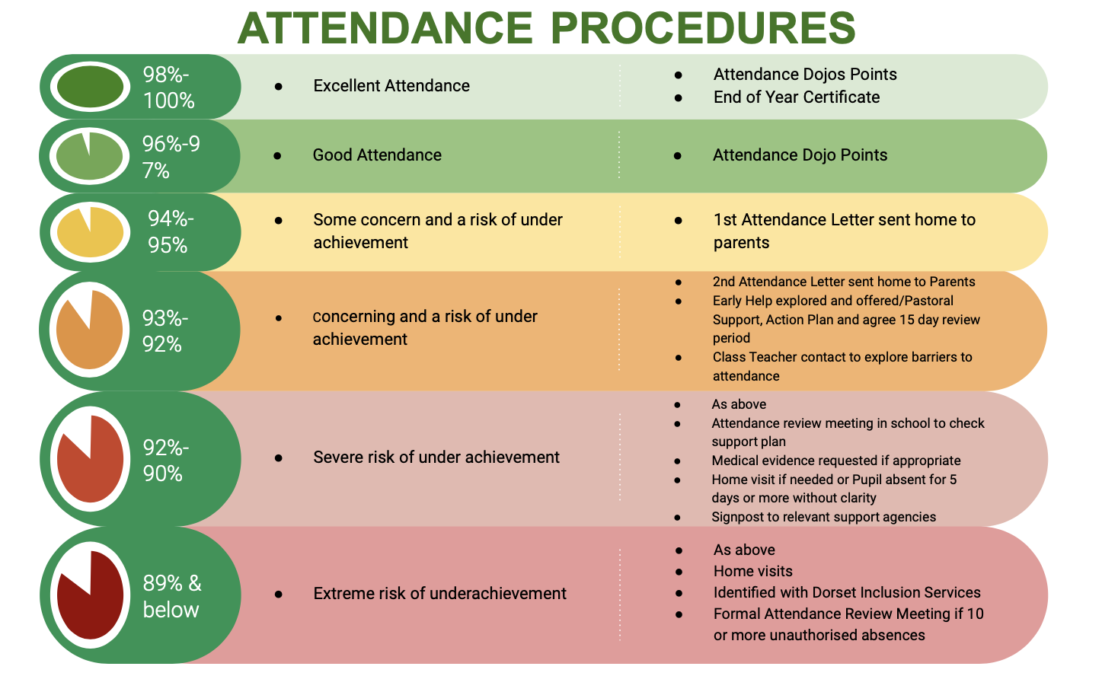
Penalties and Protocol relating to specific local authorities can be found here:
Dorset - School attendance and absence - Dorset Council
Somerset - School attendance and children missing education (somerset.gov.uk)

Absence | Procedure
Illness | Contact School Office - Open 8:30am to 4pm  - Phone and report absence via answer phone service before 8:30am or speak with a member of the office team after 8:30 am  01935 476515  or alternatively  Email: office@bradfordabbas.dorset.sch.uk  Please DO NOT use School Dojo for attendance communications.  Not all illness requires an absence from school. For minor childhood ailments such as coughs, colds, ear aches we would not expect children to be absent. However, when a parent makes the assessment that their child is unfit for school, they should follow the above absence process.  If a child is absent from school parents should contact the school on the first day of absence to inform the school of the reason for absence. Parents are expected to maintain contact with the school throughout the absence.  It is a school’s decision whether to accept a reason for a child’s absence and whether to authorise that absence. In the majority of cases, a parent’s explanation of their child’s illness can be accepted without question or concern. In circumstances where there are concerns about a child’s attendance or reason for absence, further evidence of a child’s illness may be requested.
Leave of absence request | Parents are required to complete a Term Time Leave of Absence Request Form in advance of planned absence taking place.  We ask that this is at least four weeks before the required absence, where possible, to enable the school to consider and respond to the request.  Parents must detail and evidence the exceptional circumstance of the request.  In accordance with The Education (Pupil Registration) (England) Regulations 2006 and subsequent Amendments, SAST Schools are unable to authorise any period of absence unless it is for exceptional circumstances.  If leave is not authorised and the parent proceeds to take their child out of school, the absence will be marked as unauthorised. Although such absence may be unauthorised, it is better that the school knows where the child is, and that they are safe rather than missing.  Parents may be issued with a penalty notice or be subject to prosecution by the local authority for unauthorised leaves of absence.
Medical Appointments | Parents should avoid making routine medical appointments and dental appointments during the school day. In the majority of cases, appointments can be made outside of the school day/during the school holidays.  Where appointments have to be taken during the school day, only the time for the appointment and travel to and from will be classed as an authorised absence.  Pupils are expected to return to school for the remainder of the day/attend school prior to the appointment.  Parents are required to provide a copy of an appointment letter or card prior to the day of the appointment.
Other Reasons for Absences: | Other reasons for absence must be discussed with the school on each occasion.  Notes will not necessarily be accepted as providing valid reasons.  The school will follow DFE guidance and not authorise absences for shopping, birthdays or child minding.  If we do not receive notification of your child’s absence, it will be assumed that your child is on their way to school and if they do not arrive, the absence will be followed up accordingly.  We will contact you by telephone if your child fails to arrive at school after the register has closed and no parental contact has been made. If, at the time the attendance register is taken, an absence is recorded in that register using the code N . We will ensure that reasonable steps are taken to establish the circumstances of your child's absence and that the register is amended within five school days.
Religious Observance | We recognise that children of certain faiths may need to participate in days of religious observance and that this may be a reason given for a leave of absence request.  Where a day of religious observance falls during school time and has been exclusively set apart for religious observance by the religious body to which the child belongs - the absence from school will be authorised. Parents are requested to give advance notice if they intend their child to be absent.  Evidence from the religious body may be required.

The types of scenarios when medical evidence may be requested include:
•Child is absent and there are frequent odd days absences due to reported illness
•Child is absent and the same reasons for absence are frequently repeated
•Child is absent and attendance is below expected levels and there is a concerning pattern of absence/reasons for absence.
•Where there is a medical problem and school may need evidence to seek additional support/provide support may fall outside school holiday periods or weekends and this necessitates a consideration of authorised absence.

Pupils with a social worker
We will inform a pupil’s social worker if there are unexplained absences from school.

Legislation, statutory guidance, linked SAST policies
Our School attendance policies complies with the legal frameworks, statutory requirements and relevant guidance laid out in the following:

• Working together to improve school attendance (2024)
• Summary table of responsibilities for school attendance (2024)
• Toolkit for schools: communicating with families to support attendance (2024)
• The School Attendance (Pupil Registration) (England) Regulations (2024)
• Working Together to Safeguard Children (2023)
• Children Missing Education Statutory Guidance (2016)
• Supporting pupils at school with medical conditions (2015)
• Home to school travel and transport (2014)
• School behaviour and attendance: parental responsibility measures (2020)
• Responsibilities where a mental health issue is affecting attendance (2023)
• Alternative provision (2013)
• Common Transfer File (2019)
• Equality Act (2010)
• Children and Families Act 2014 (legislation.gov.uk)

Our School attendance policy reflects and references the following statutory guidance and SAST policies:
• Keeping children safe in education 2024
• Behaviour in Schools Advice for headteachers and school staff (2022)
• SAST Inclusion, Suspension and Exclusion Policy
• SAST Equality and Diversity Policy
• SAST Supporting Children with Medical Needs Policy
• SAST Children with Health Needs Who Cannot Attend School Policy
• SAST SEND Policy
• SAST Behaviour Principles
• School safeguarding policies
• SAST Guidance on Reduced Timetables and Flexi-schooling
• Any guidance from a school’s own local authority relating to Children Missing in Education
(CME), Children Missing out on Education (CMOOE), penalty notices, suspension and exclusion.

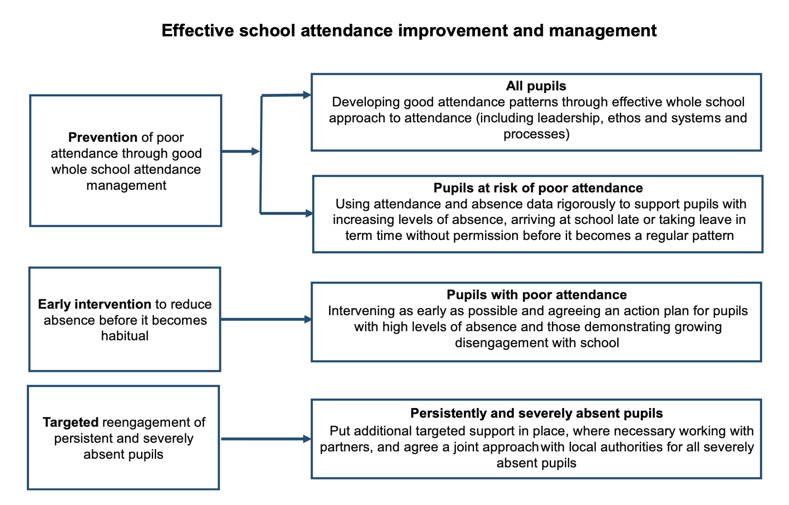
Above diagram from ‘Working together to improve school attendance’ (Published 29th February 2024 and applied from 19th August 2024)

